**VPC Creation Assignment**

**Problem Statement:**

Working for an organization, you are required to provide them a safe and secure environment for the deployment of their resources. They might require different types of connectivity. Implement the following to fulfill the requirements of the company.

**Tasks to Be Performed:**

1. Create a VPC with 120.0.0.0/16 CIDR block.

2. Create 1 public subnet 2 private subnets and make sure you connect a NAT gateway for internet connectivity to a private subnet.

**Problem (1) Solution:** Create a VPC with 120.0.0.0/16 CIDR block.

**Step 1: Go** tothe **“Services”** section **& search** the **“VPC”** in the **search box. Put cursor** over the **“VPC”** & **click** onthe **“Your VPC”.**

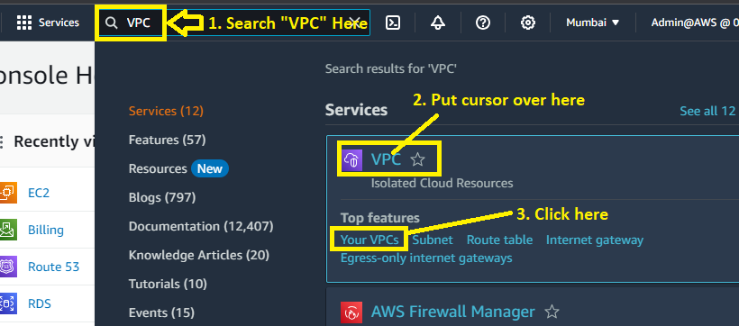

**Step 2: Click** onthe **“Create VPC”.**

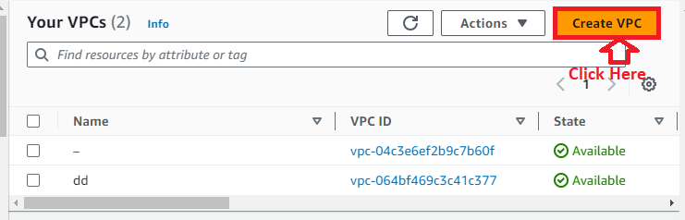

**Step 3: Choose** the **following options** inthe **“VPC Settings”:**

**Resources to create:** VPC only

**Name tag – optional:** My-First-Custom-VPC

**IPv4 CIDR block:** IPv4 CIDR manual input

**IPv4 CIDR:** 120.0.0.0/16

**IPv6 CIDR block:** No IPv6 CIDR block

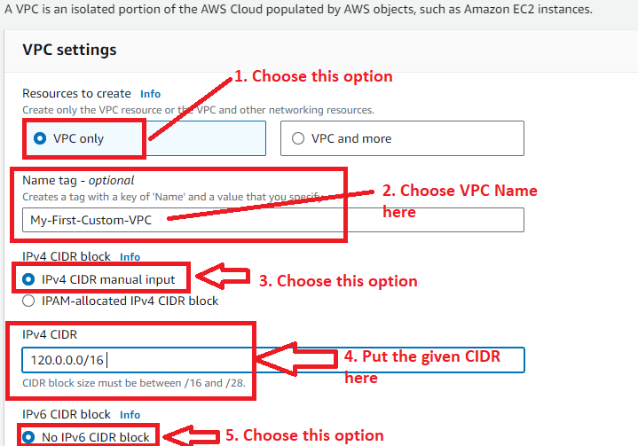

**Tenancy:** Default

**Tags:** Choose the **“Name”** as the **“My-First-Custom-VPC”.**

**Click** on the **“Create VPC”.**

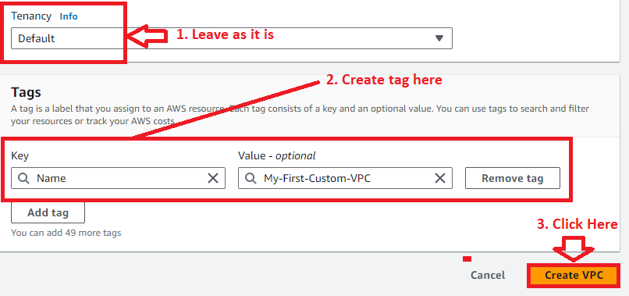

**Step 4: Your VPC (My-First-Custom-VPC)** has been **successfully created** using the **120.0.0.0/16 CIDR Block. You** can **view** all the **VPC details here.**

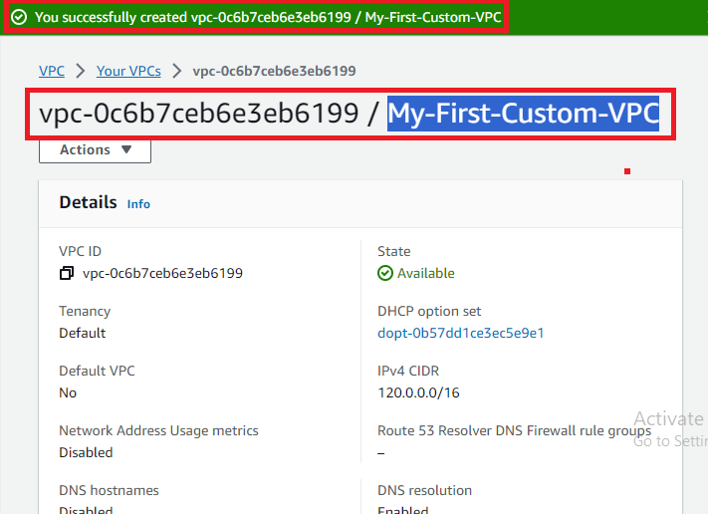

**Problem (2) Solution:** Create 1 public subnet 2 private subnets and make sure you connect a NAT gateway for internet connectivity to a private subnet.

**A. Create 1 Public Subnet Here**

**Step 1: Click** onthe **“Subnets”** in the **left side bar** ofthe **“VPC Dashboard”.**

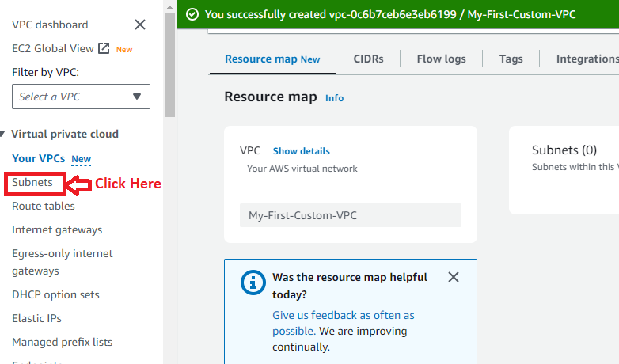

**Step 2: Click** on the **“Create subnet”.**

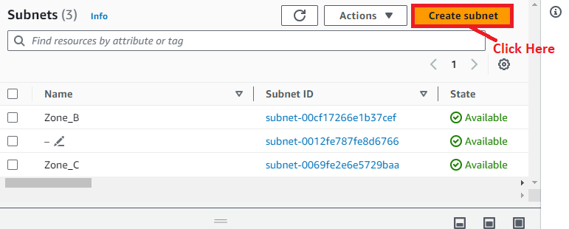

**Step 3: Select** a **VPC** in **the “VPC ID”. We** will **select** the **“My-First-Custom-VPC” id** here**.**

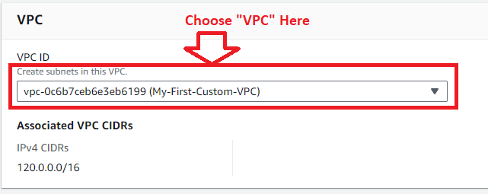

**Step 4: In** the **“Subnet Settings”, first we** will **create** a **public subnet** here**. Choose** the **following options** here**:**

**Choose** the **“Subnet Name”** as the **“My-First-Public-Subnet”.**

**Choose** the **“Availability Zone”** as the **“Asia Pacific (Mumbai) /ap-south-1a”.**

**Leave** the **“IPv4 VPC CIDR Block”** as the **“120.0.0.0/16”.**

**Choose** the **“IPv4 Subnet CIDR block”** as the **“120.0.128.0/17”.**

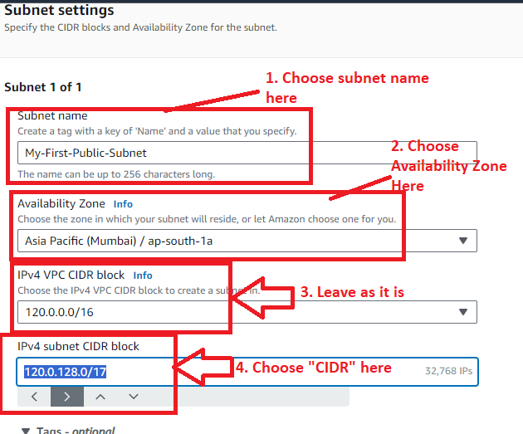

**Choose** the **“Name”** as the **My-First-Public-Subnet”** in **the “Tags”** section**.**

**Click** on the **“Create subnet”.**

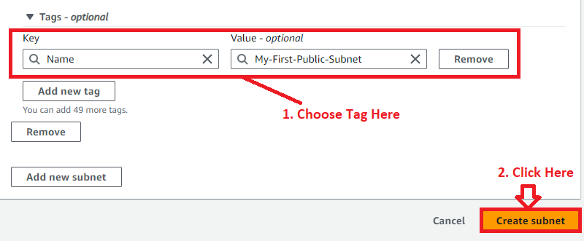

**Step 5:** The **“subnet (My-First-Public-Subnet)”** will be **successfully created.**

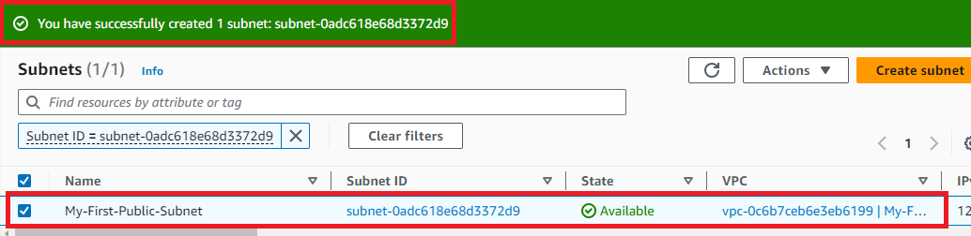

**Step 6: When we select** the **created VPC, the main route table** has been **successfully attached** to the **“My-First-Public-Subnet”. You** can **view** the **“Route table”** section& **the main route table** will be **present there.**

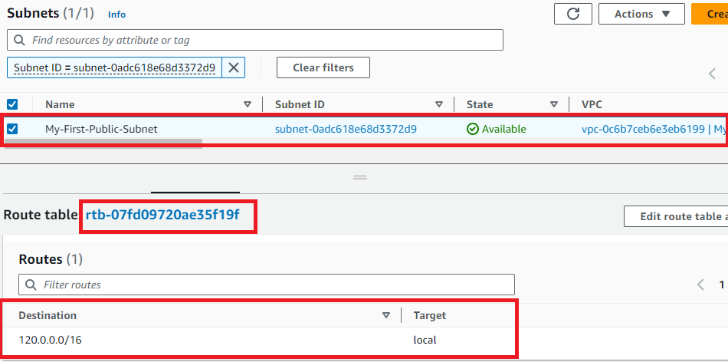

**Step 7: Now, we** will **click** on the **“Enable Auto Assign IP” option** to **automatically assign** the **IP Address** to the **“Public Subnet”.**

**Choose** the **“My-First-Public-Subnet”** & **go** to the **“Actions”. Click** onthe **“Edit subnet settings”.**

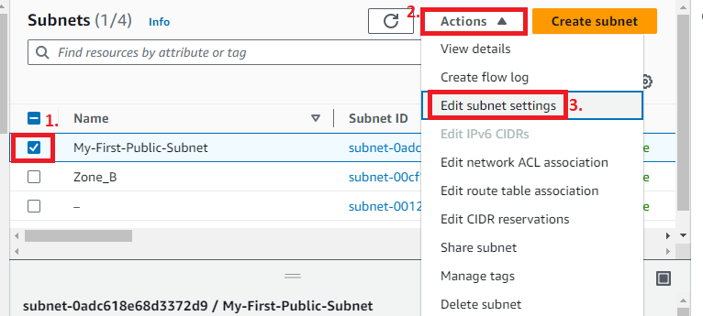

**Step 8: Enable** the **option “Enable auto-assign public IPv4 address”** through **“ticking”** this **option.**

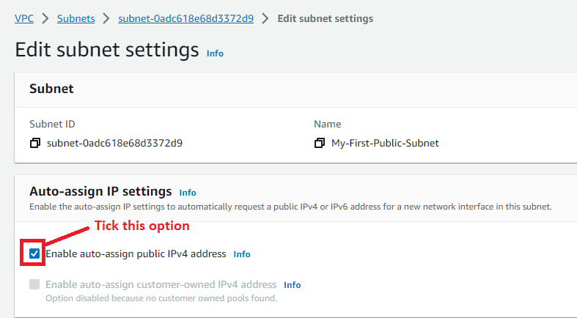

**Step 9: Leave all** the **settings** by **default** & **click** on the **“Save”.**

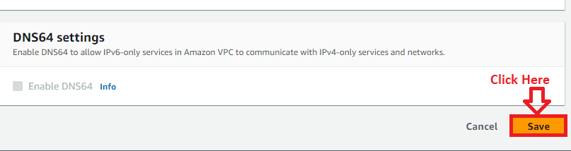

**Step 10: The subnet settings** will be **successfully saved.**

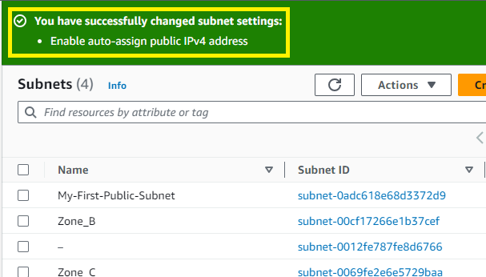

**B. Create & Attach Internet Gateway (IGW) to VPC**

**Step 1: Click** onthe **“Internet gateways”.**

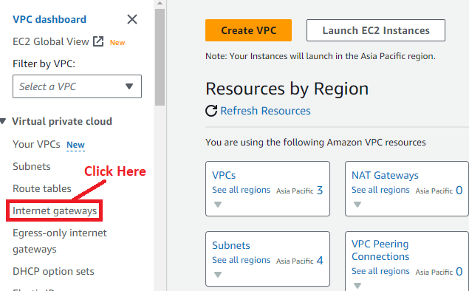

**Step 2: Click** onthe **“Create internet gateway”.**

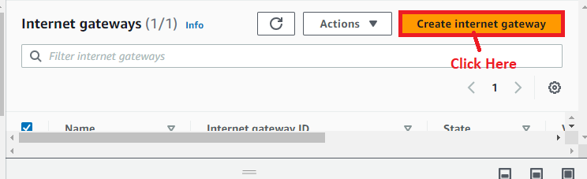

**Step 3: Choose** the **“Name tag”** as the **“My-First-IGW”. While** the **“Tags-optional”, the name** & **value** will be **automatically taken. Click** onthe **“Create internet gateway”.**

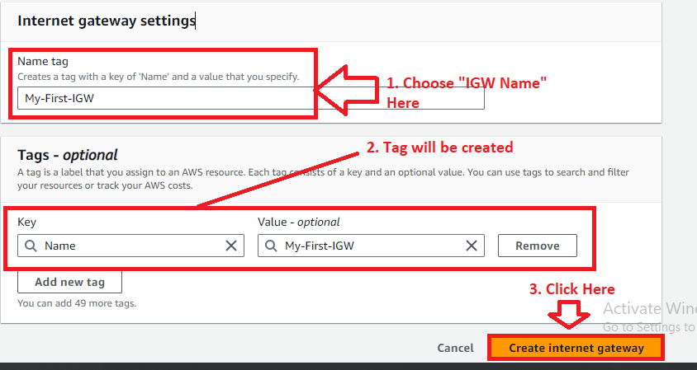

**Step 4: Your Internet Gateway (My-First-IGW)** has been **successfully created.**

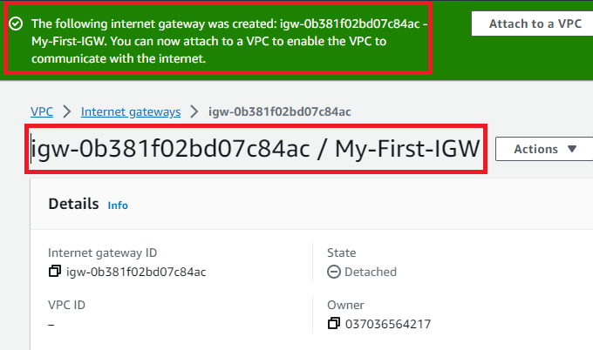

**Step 5: Now, we** will **attach** the **Internet Gateway** to **created VPC** for **accessing** the **internet. Click** onthe **“Attach to a VPC”.**

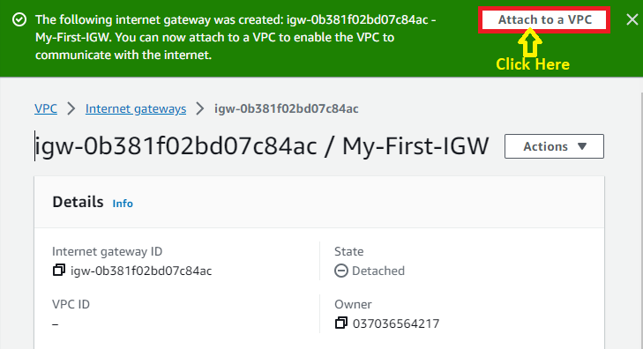

**Step 6: Select** the **“My-First-Custom-VPC (vpc-0c6b7ceb6e3eb6199)” here, which we** have **created** with **120.0.0.0/16 CIDR. Click** onthe **“Attach Internet Gateway”.**

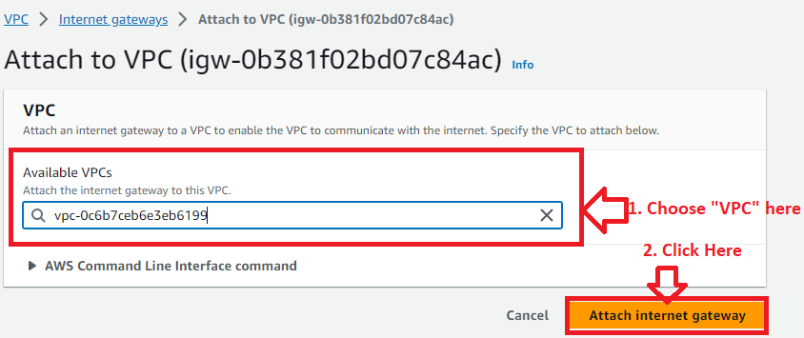

**Step 7: The “Internet gateway (My-First-IGW)** has been **successfully attached** tothe **“My-First-Custom-VPC”. You** can **view** the **details** inthe **“IGW Details”.**

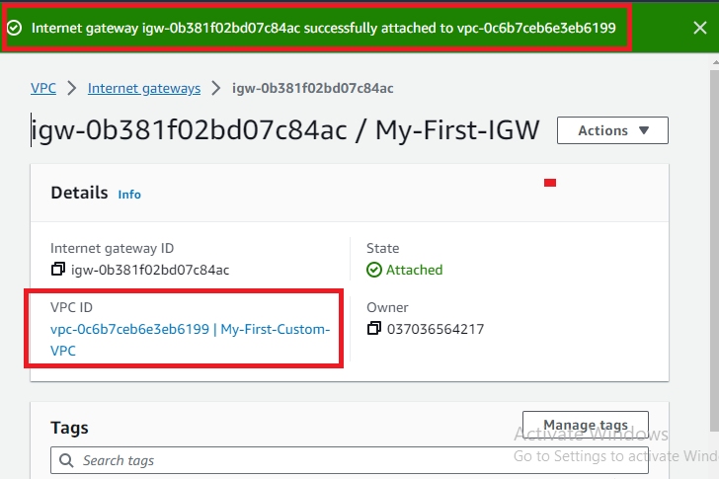

**C. Attach Internet Gateway to Subnet via Route Table Entry**

**Step 1: Click** onthe **“Route tables”.**

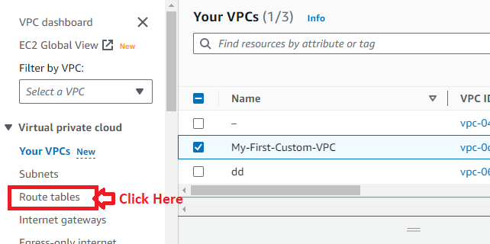

**Step 2: Select** the **associated route table (rtb-07fd09720ae35f19f)** withthe **VPC** & **Click** on the **“Actions”. In** the **“Actions”, click** onthe **“Edit routes”.**

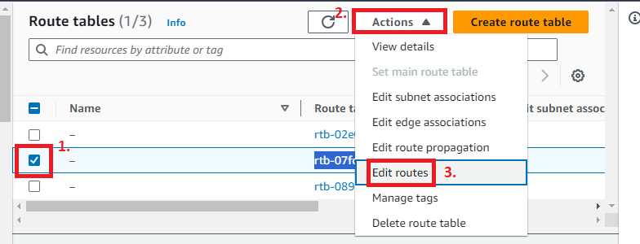

**Step 3: Click** onthe **“Add Route”.**

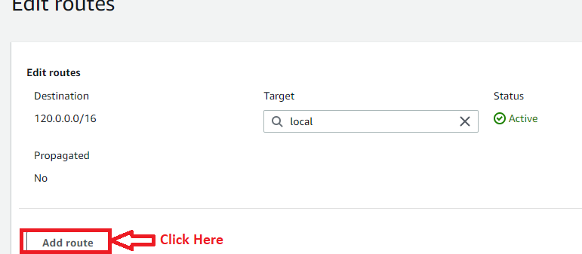

**Step 4: Choose** the **“Destination”** as the **“0.0.0.0/0” & “Target”** asthe **“Internet Gateway”.**

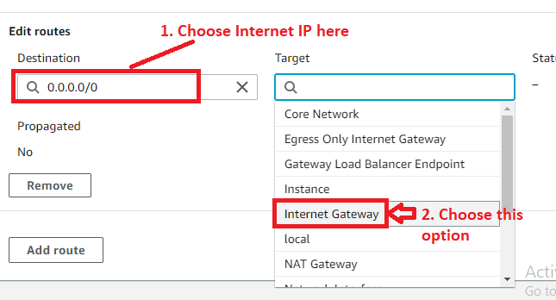

**Step 5: Choose** your **“Internet Gateway (igw-0b381f02bd07c84ac)”** as the **“Target”. Click** on the **“Save Changes”.**

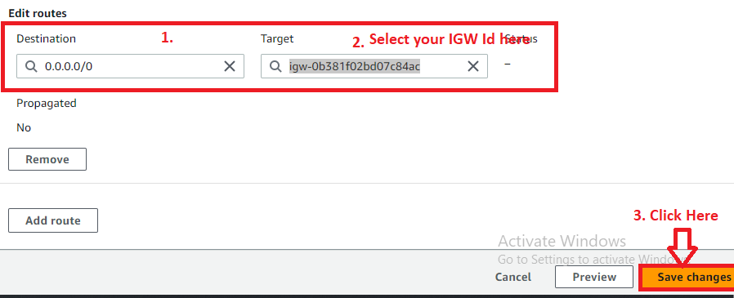

**Step 6: Your routes** has been **successfully updated. You** can **view** the **route settings** in the **“Routes” section.**

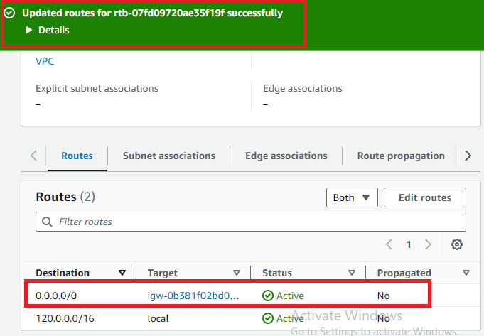

**Step 7: Click** on the **“Your VPC”.**

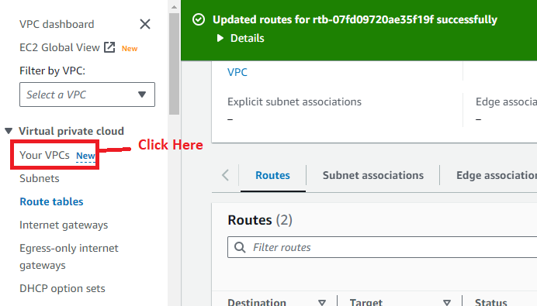

**Step 8: Choose** your **custom created VPC** & **go** to the **“Resource map”. You** will **notice** that **your IGW (Internet Gateway)** has been **successfully attached** to the **main route table, which** is **associated** with **the “public subnet”.**

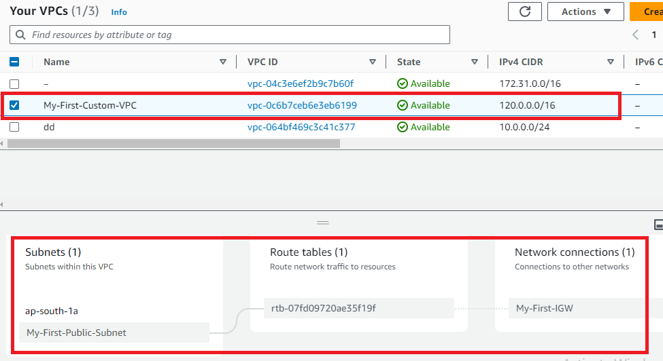

**D. Create a Route Table for Private Subnets**

**Step 1: Click** onthe **“Route tables”.**

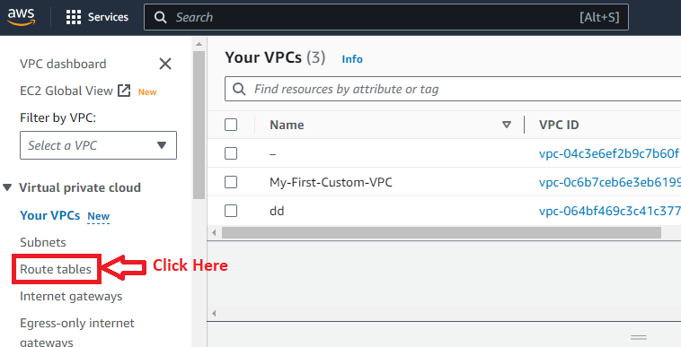

**Step 2: Click** on the **“Create route table”.**

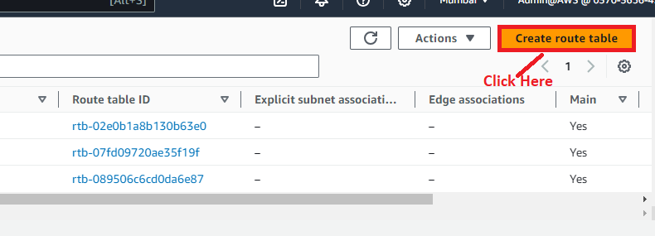

**Step 3: Choose** the **following options** for **creating** the **private route table.**

**a. “Name- optional”** as **“My-Private-Route-Table”.**

**b. VPC:** “My-First-Custom-VPC”.

**c. Tags Entry -** Name: My-Private-Route-Table

**Click** on the **“Create route table”.**

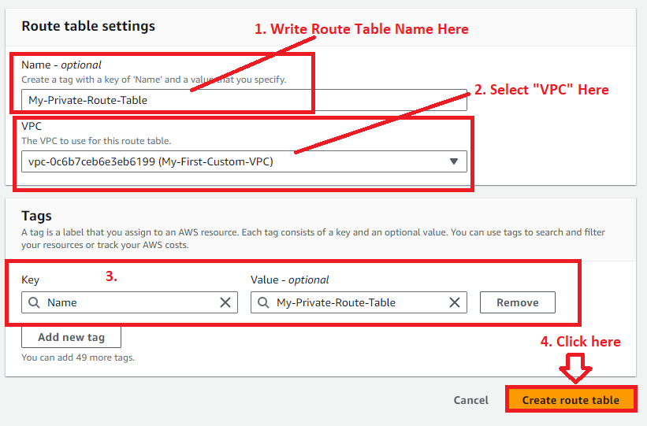

**Step 4: A private route table name** as **“rtb-071da307ec66fb008 / My-Private-Route-Table”** has been **successfully created** withthe **associated details.**

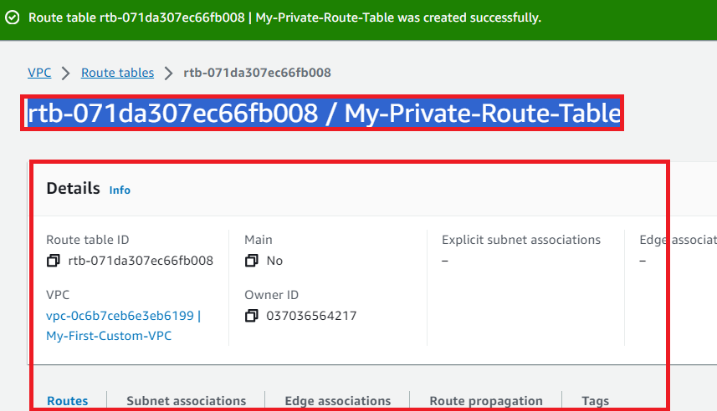

**E. Create 2 Private Subnets Here & Associate Private Route Table**

**Step 1: Click** on the **“Subnets”.**

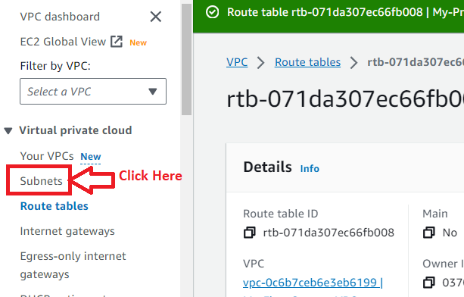

**Step 2: Click** on the **“Create Subnet”.**

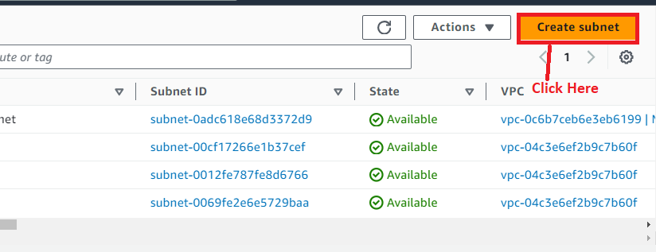

**Step 3: Choose** the **“VPC ID”** asthe **“vpc-0c6b7ceb6e3eb6199 (My-First-Custom-VPC)”.**

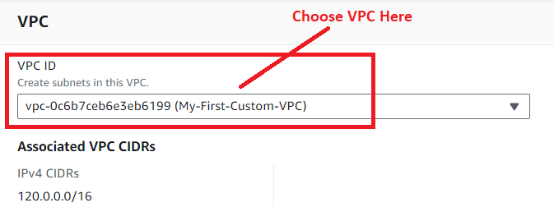

**Step 4: In** the **“Subnet 1 of 1”, Choose** the **following options** here:

**Subnet name:** My-First-Private-Subnet

**Availability Zone**: Asia pacific (Mumbai)/ap-south-1b

**IPv4 VPC CIDR block:** 120.0.0.0/16

**IPv4 subnet CIDR block:** 120.0.32.0/20

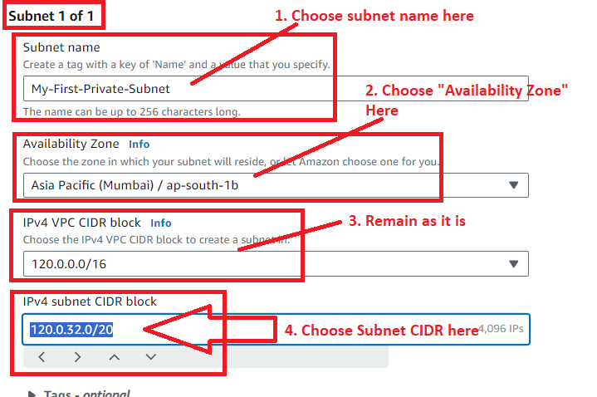

**Step 5: Click** on the **“Add new subnet”.**

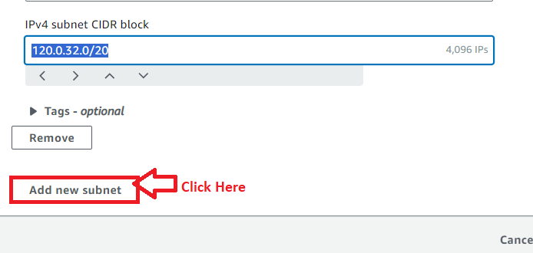

**Step 6: In** the **“Subnet 2 of 2”, choose** the **following options here:**

**Subnet name -** My-Second-Private-Subnet

**Availability Zone -** Asia pacific (Mumbai)/ap-south-1c

**IPv4 VPC CIDR block:** 120.0.0.0/16

**IPv4 subnet CIDR block:** 120.0.32.0/20

**IPv4 subnet CIDR block:** 120.0.16.0/20

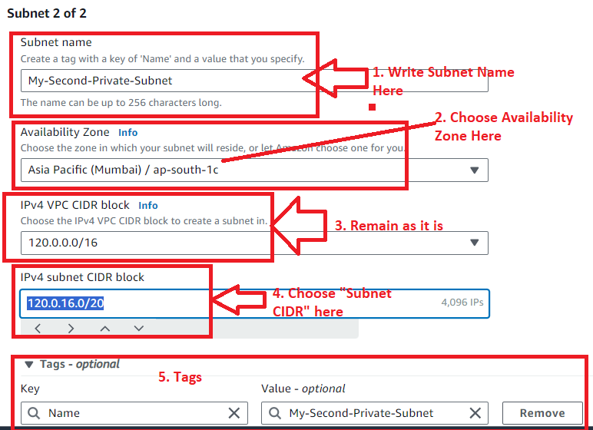

**Step 7: Click** onthe **“Create subnet”.**

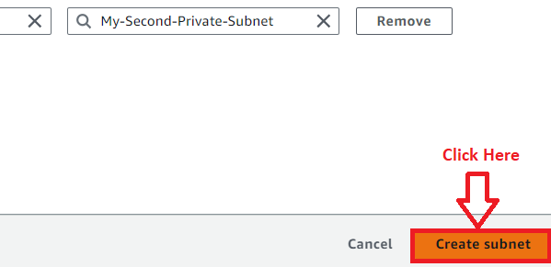

**Step 8: Your private subnets** will be **successfully created.**

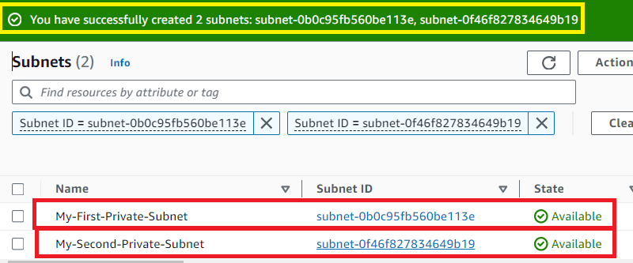

**Step 9: Choose** the **“My-First-Private-Subnet”** & **go** tothe **“Actions>Edit route table association”.**

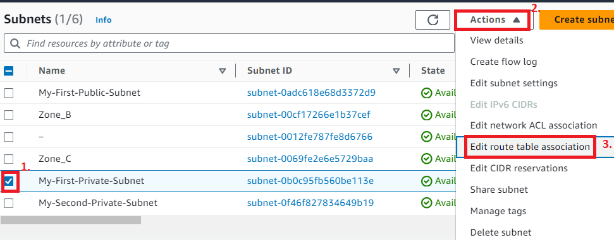

**Step 10: Select** the **“Route Table Id”** asthe **“My-Private-Route-Table”. Click** onthe **“Save”.**

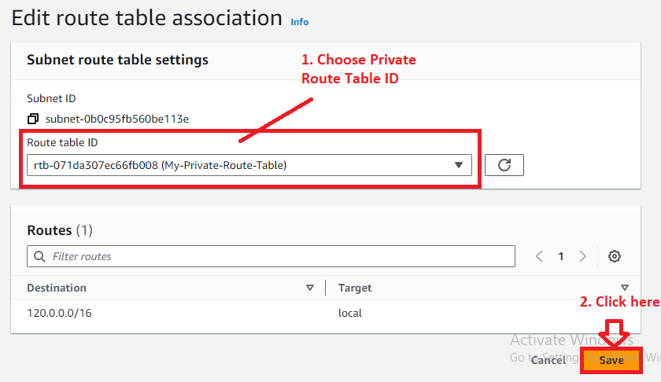

**Step 11: Your private route table** has been **successfully associated** withthe **“My-First-Private-Subnet”.**

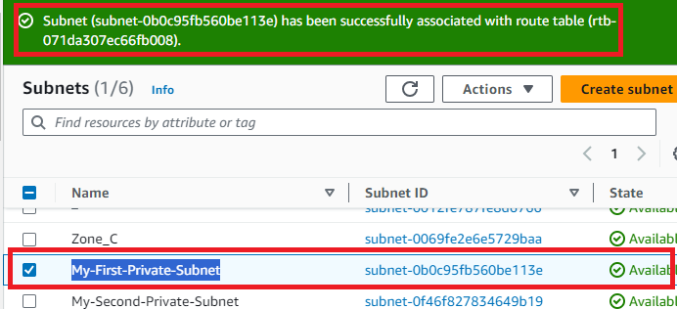

**Step 12: Choose** the **“My-Second-Private-Subnet”** & **go** to the **“Actions>Edit route table association”.**

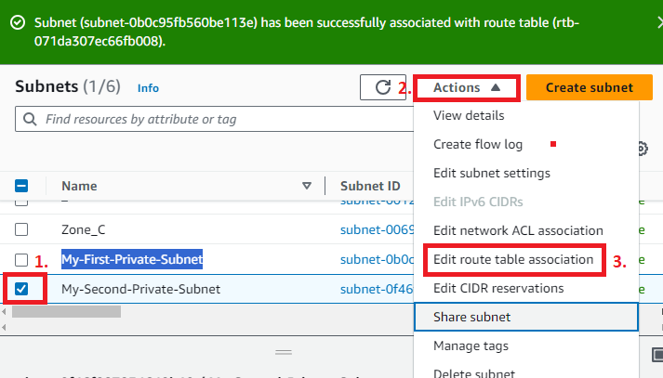

**Step 13: Choose** the **“Route Table Id”** as the **“My-Private-Route-Table”. Click** on the **“Save”.**

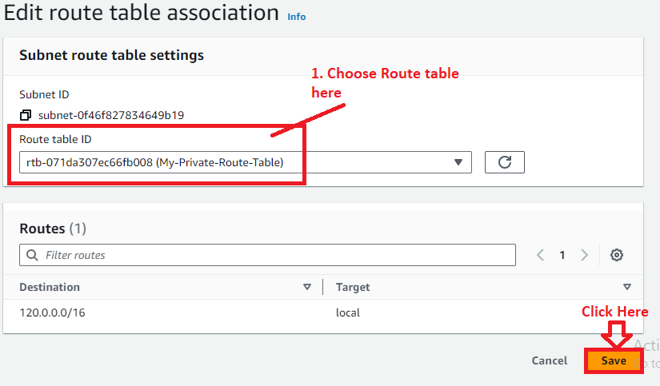

**Step 14: Your private route table** has been **successfully associated** withthe **“My-Second-Private-Subnet”.**

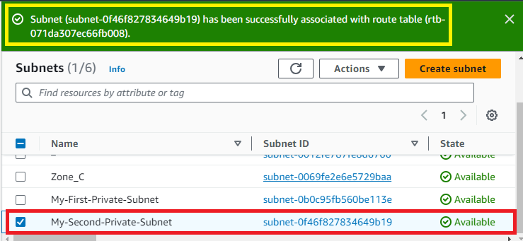

**F. Create a NAT Gateway & Attach it to the Public Subnet for Internet Access to Private Subnet Instances**

**Step 1: Click** on the **“NAT Gateway”** in the **left side menu bar.**

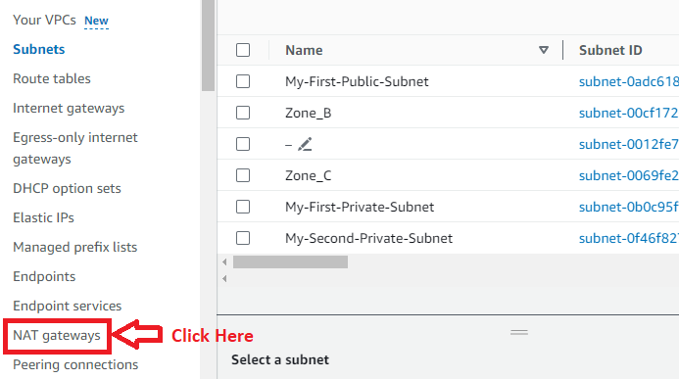

**Step 2: Click** on the **“Create NAT Gateway”.**

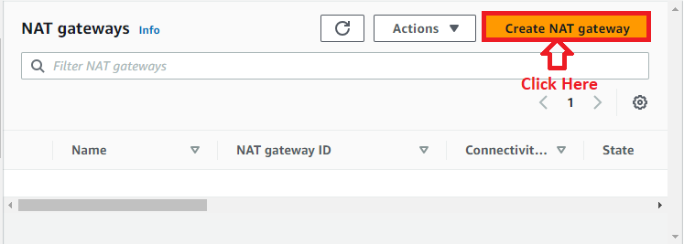

**Step 3: In** the **“NAT gateway settings”, choose** the **following options:**

**Name -** My-First-NAT-Gateway

**Subnet –** subnet-0adc618e68d3372d9 (My-First-Public-Subnet)

**Connectivity Type –** Public

**Elastic IP allocation ID** – **Click** on the **“Allocate Elastic IP” – Automatically** allocates **Elastic IP. [eipalloc-06ec4a5ae9e919925 – 65.1.196.54]**

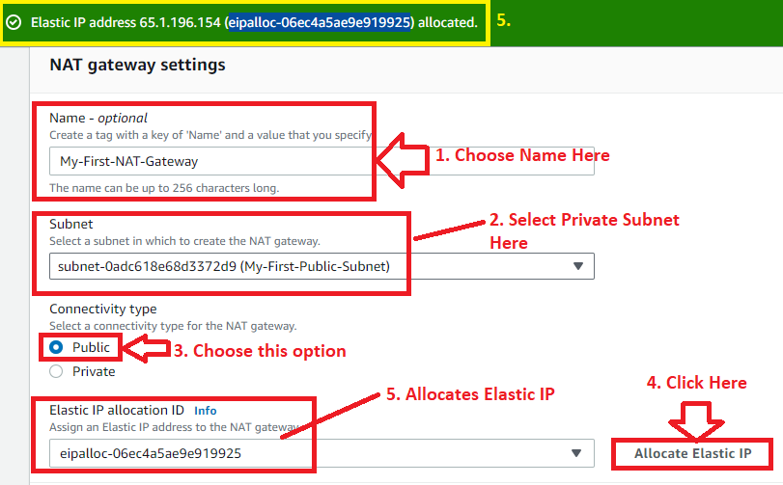

**The tags** will be **automatically created. Click** on the **“Create NAT gateway”.**

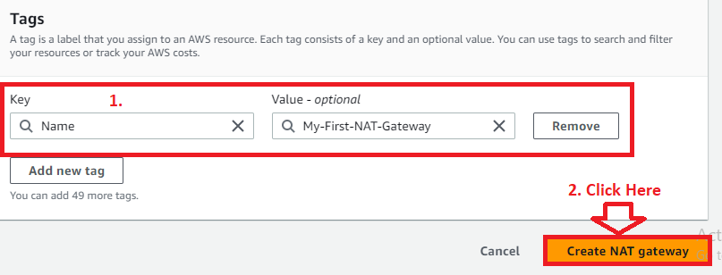

**Step 4: Your “NAT Gateway”** will be **successfully created** &the **message** will be **displayed.**

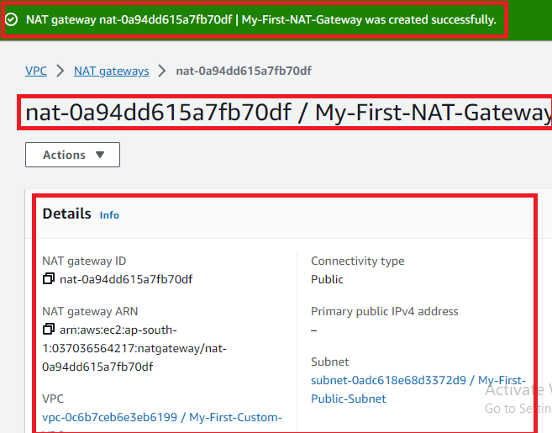

**G. Do NAT Gateway entry to the Private Route Table for Connecting Private Subnet to NAT Gateway**

**Step 1: Go** to the **“Route tables”.**

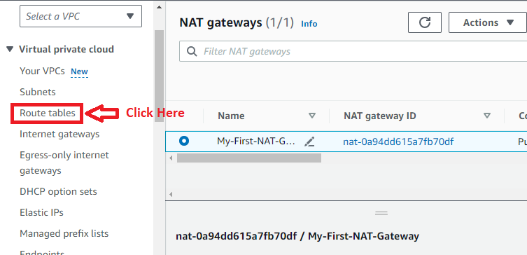

**Step 2: Select** the **“My-Private-Route-Table”** & **go** tothe **“Actions>Edit routes”.**

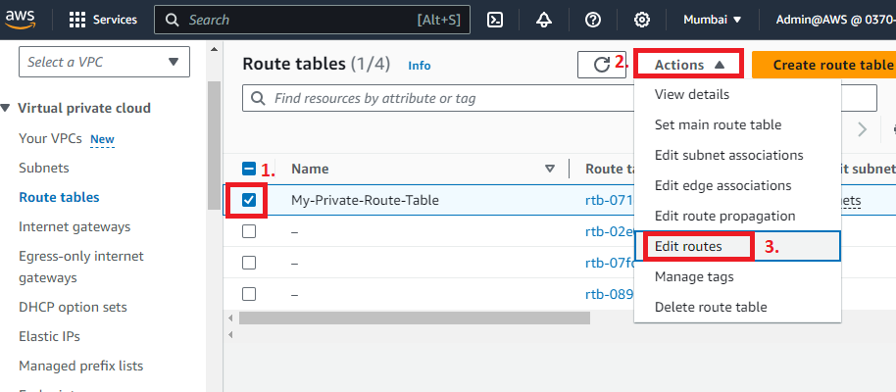

**Step 3: Click** onthe **“Add route”.**

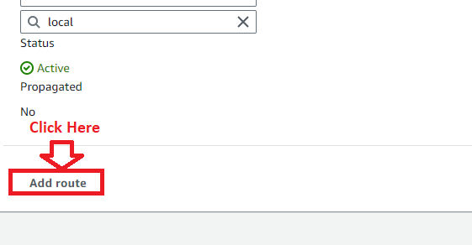

**Step 4: Choose** the **“Destination”** as the **“0.0.0.0/0”** & **“Target”** as the **“NAT Gateway”.**

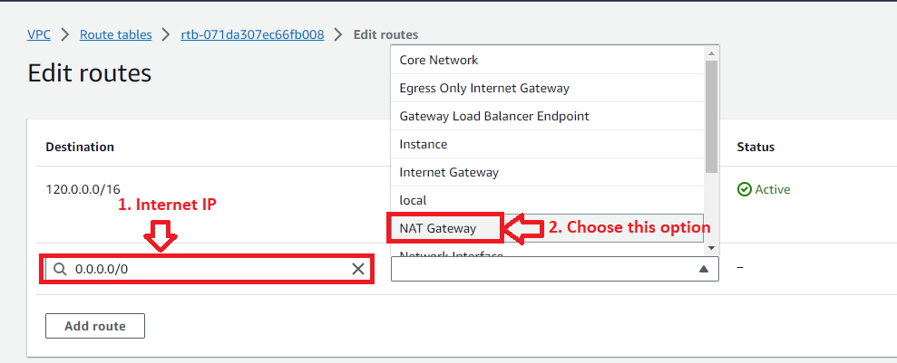

**Step 5: Choose** your **NAT Gateway Id (nat-0a94dd615a7fb70df)** & **click** onthe **“Save changes”.**

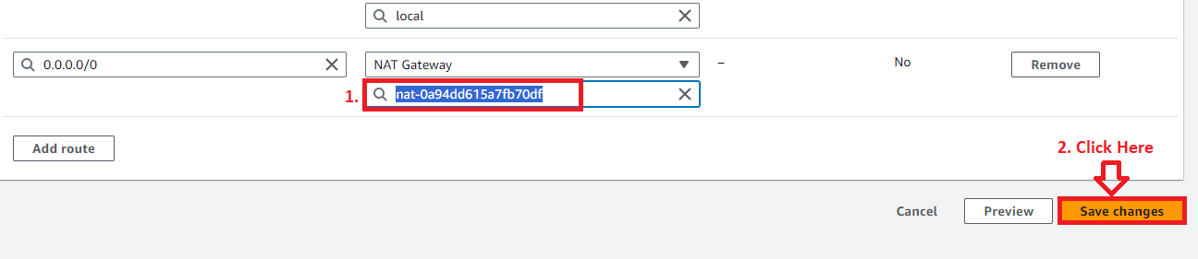

**Step 6: The routes** will be **successfully updated.**

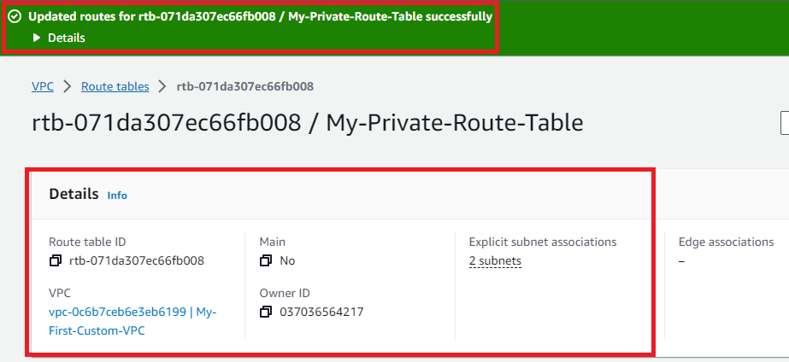

**Step 7: Go** to the **“Your VPC”** & **select “My-First-Custom-VPC”. In** the **“Resource Map”, you** will **notice** that **“NAT Gateway”** has been **successfully connected** tothe **“My-Private-Route-Table”, which** is **connected** with **both the subnets.**

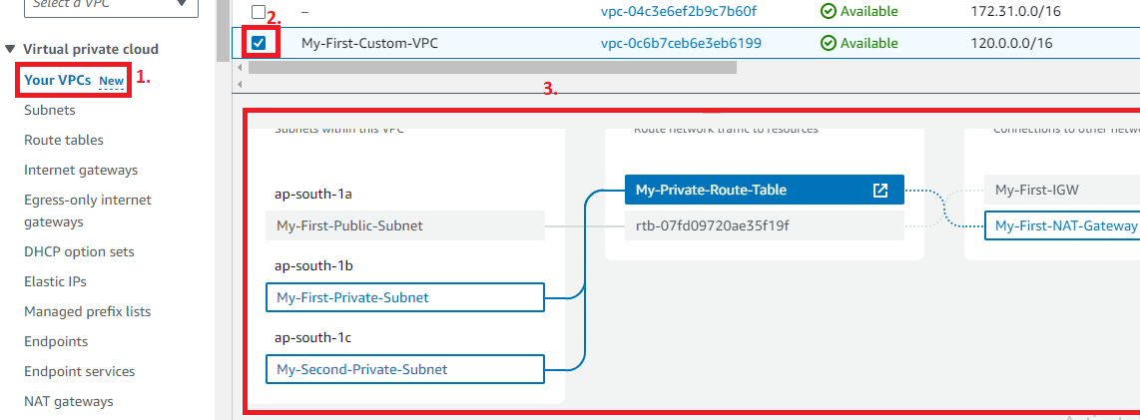

**H. Launch 3 Instances (One Instance into Public Subnet & Two Instances into Both Private Subnets) in the Custom VPC**

**1. Launch the First Instance into the Public Subnet:- (My-First-Public-Subnet)**

**Step 1: Go** tothe **“Services>EC2”.**

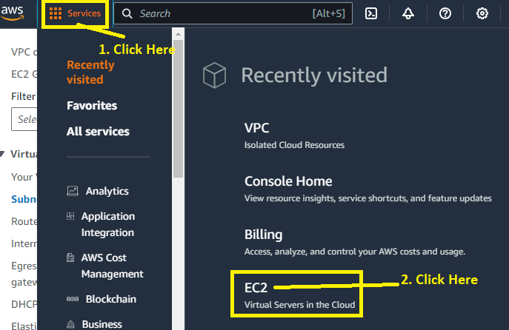

**Step 2: Click** onthe **“Launch Instance”.**

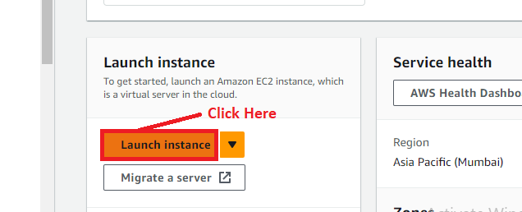

**Step 3: Choose** the **“Name”** asthe **“My-Public-Instance”** in the **“Name and tags” section.**

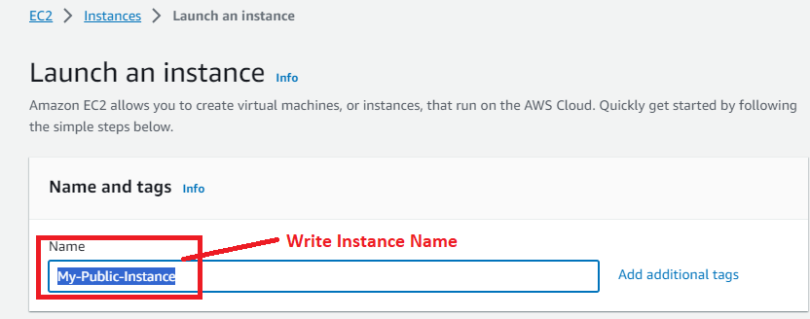

**Step 4: Choose** the **“Application and OS Images (Amazon Machine Images)”** as **“Amazon Linux”.**

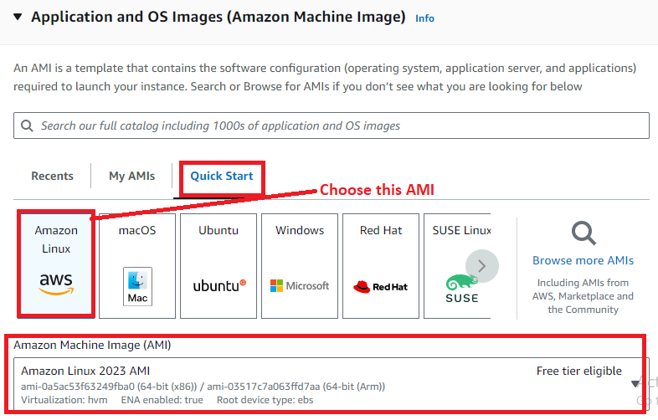

**Step 5: Select** the **“Instance type”** as the **“t2.micro”.**

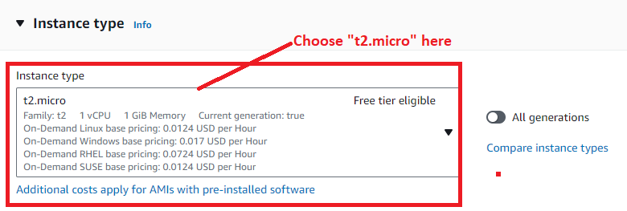

**Step 6: Select** the **“Key pair (login)”** asthe **“MY-WEB-SERVER”. You** can **create** your **new key pair login.**

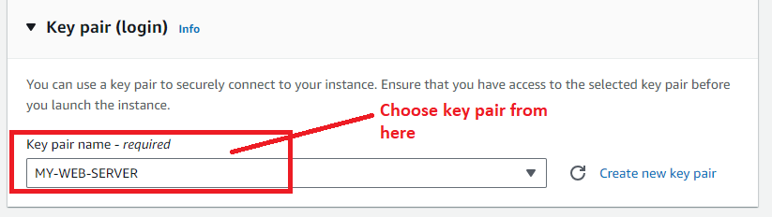

**Step 7: Click** on the **“Edit”** in the **“Network Settings”.**

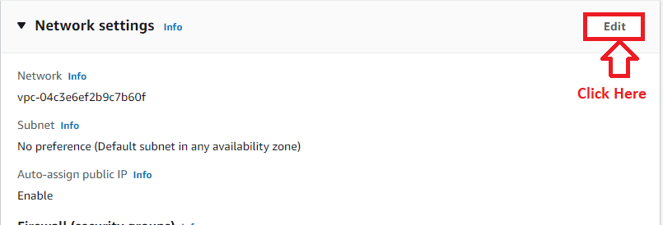

**Step 8: Select** the **“VPC”** as the **“My-First-Custom-VPC”. The “Subnet”** & **“Auto Assign IP” automatically selected** asthe **“My-First-Public-Subnet”** & **“Enable” respectively.**

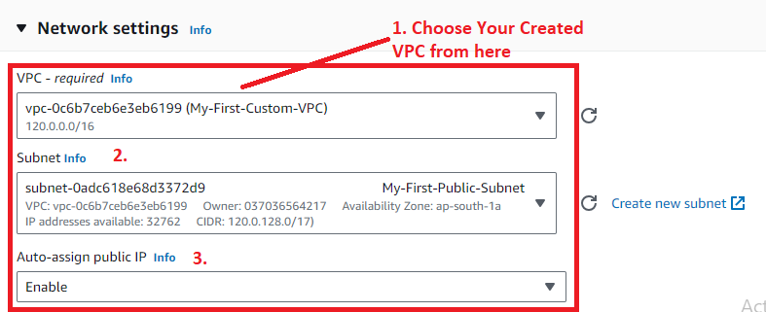

**Step 9: In** the **“Firewall (security groups)”, select** the **“Create security group”. While** inthe **“Security group Name”, write** the **name** as the **“VPC-Security-Group”. In** the **“Description”, write** the **description** asthe **“Security Group for VPC”.**

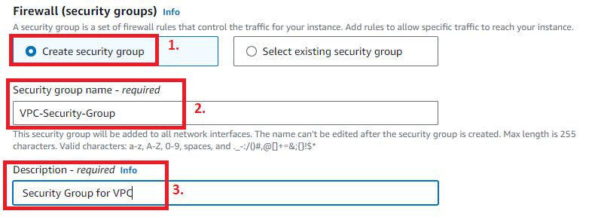

**Step 10: In** the **“Inbound Security Group Rules”, select** the **“Type”** as **“All Traffic”** &the **“Source type”** as **“Anywhere”.**

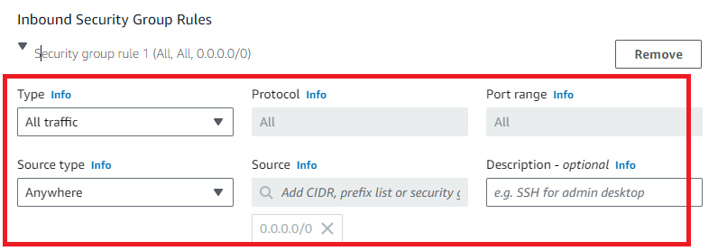

**Step 11: Leave** the **other settings** as **it is** & **click** onthe **“Launch Instance”.**

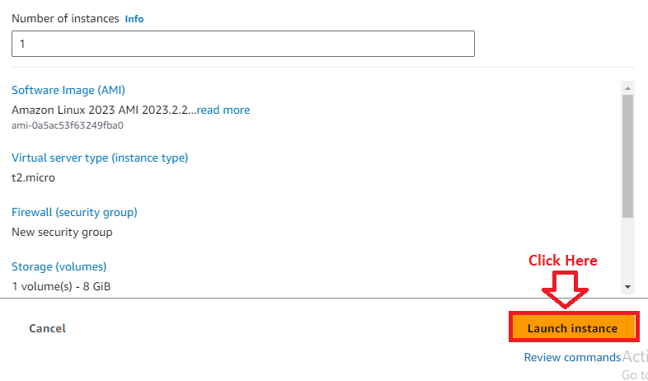

**Step 12: The instance** will be **launched successfully. Click** onthe **“hyperlink”, which** is an **instance id.**

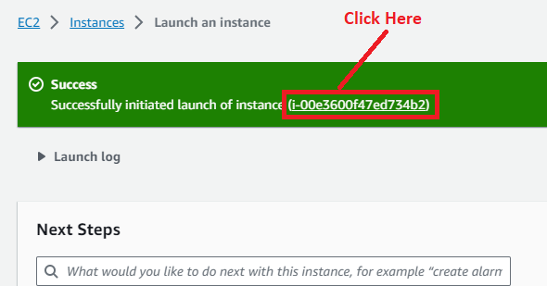

**Step 13: The Instance (My-Public-Instance)** will be **in** the **“Running State”. Select** the **“Instance”** & **click** onthe **“Connect”.**

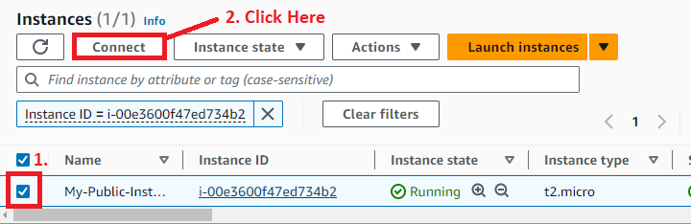

**Step 14: Click** onthe **“Connect”** inthe **“EC2 Instance Connect”.**

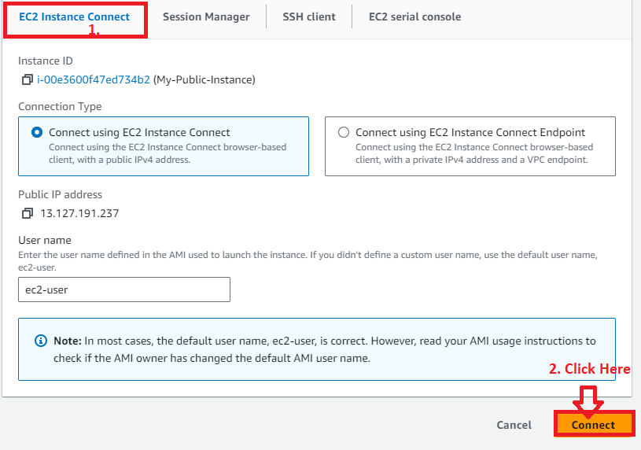

**Step 15: The instance** will be **successfully connecting. It means, all** the **settings** in the **“VPC”** is **fine.**

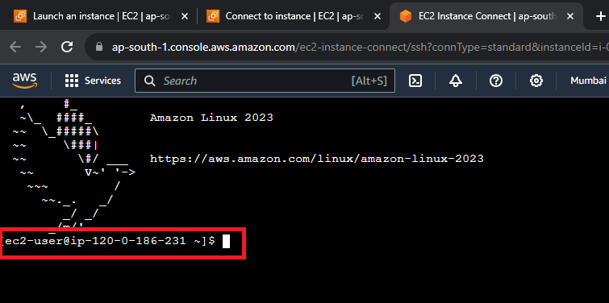

**We** will **run some command, all** is **working fine** on the **Public Instance.**

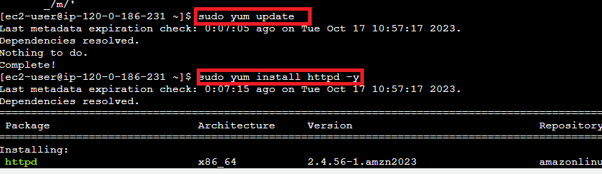

**2. Launch the Second Instance into First Private Subnet:- (My-First-Private-Subnet)**

**Step 1: Click** on the **“Launch Instances”.**

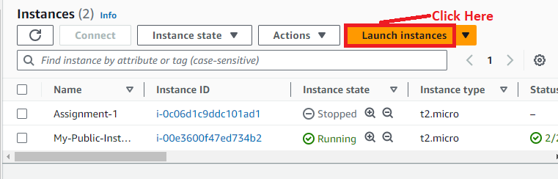

**Step 2: Write** the **“Name”** asthe **“My-First-Private-Instance”** in the **“Name and tags”** section.

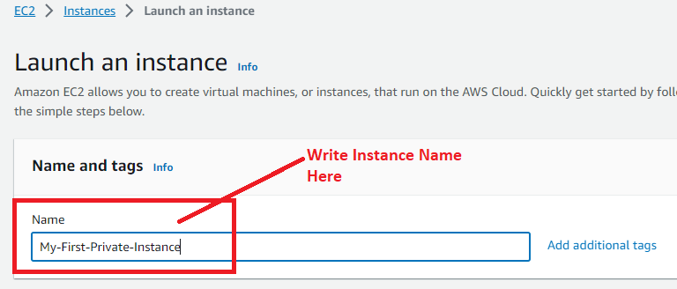

**Step 3: Choose** the **“Application and OS Images (Amazon Machine Images)”** as the **“Amazon Linux”.**



**Step 4: Select** the **“Instance type”** asthe **“t2.micro”.**



**Step 5: Select** the **“Key pair (login)”** asthe **“MY-WEB-SERVER”. You** can **create** your **new key pair login.**



**Step 6: Click** onthe **“Edit”** inthe **“Network Settings”.**



**Step 7: Select** the **“VPC”** as the **“My-First-Custom-VPC”. Select** the **“Subnet”** as the **“My-First-Private-Subnet”** & the **“Auto-assign public IP”** will be **automatically** **selected** as **“Disable”.**

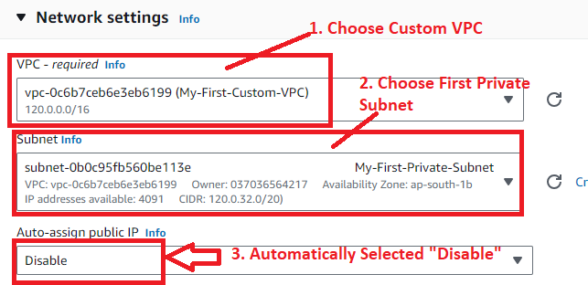

**Step 8: In** the **“Firewall (security groups)”, select** the **“Create security group”. While** in the **“Security group Name”, write** the **name** as the **“VPC-Private-Security-Group”. In** the **“Description”, write** the **description** asthe **“Security Group for Private VPC”.**

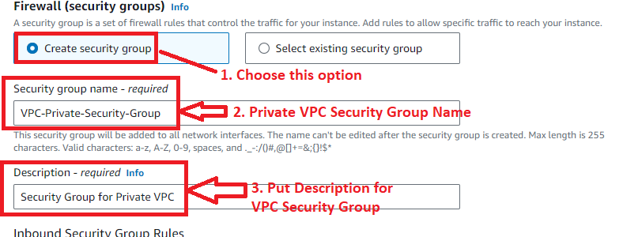

**Step 9: In** the **“Inbound Security Group Rules”, select** the **“Type”** as the **“SSH” &** the **“Source type”** asthe **“Custom”. Put** the **“Source”** as the **“Public Subnet CIDR (120.0.128.0/17”** here**.**

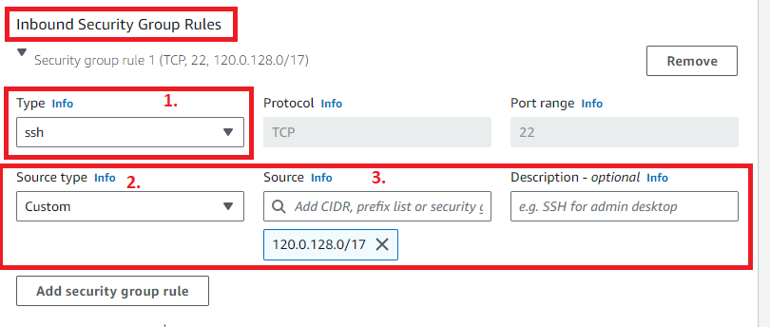

**Step 10: Leave** the **other settings** as **it is** & **click** onthe **“Launch Instance”.**



**Step 11: The instance** will be **launched successfully. Click** on the **“hyperlink”, which** isan **instance id.**

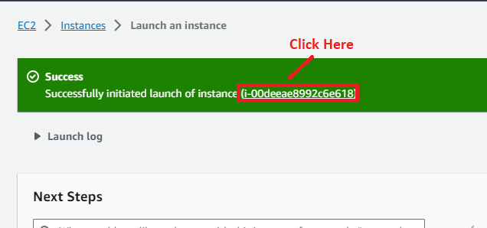

**Step 12: The instance** will be **in** the **“Running” State. It** means **our First Private Instance** has been **successfully created. The private Instance** can’t be **connected publicly that’s why we don’t have perform** the **connection here. We** will **connect** throughthe **public Instance** after **both** the **private instance** creation**.**

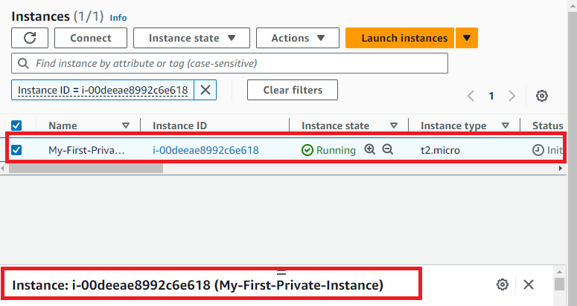

**3. Launch the Third Instance into Second Private Subnet:- (My-Second-Private-Subnet)**

**Step 1: Click** on the **“Launch Instances”.**



**Step 2: Select** the **“Name”** asthe **“My-Second-Private-Instance”** in the **“Name and tags”.**

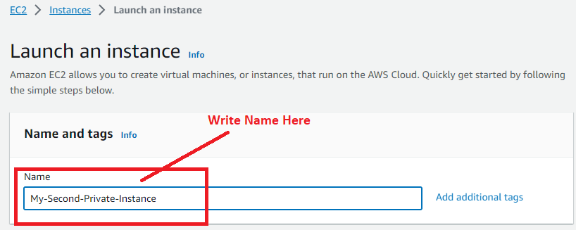

**Step 3: Select** the **“Application and OS Images (Amazon Machine Images)”** as **“Amazon Linux”.**



**Step 4: Select** the **“Instance type”** as **“t3.micro”.**

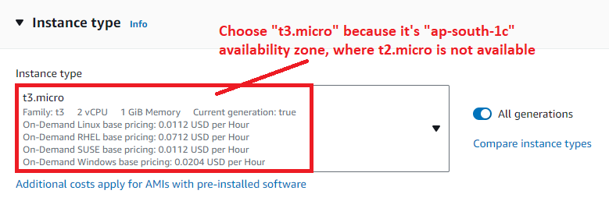

**Step 5: Select** the **“Key pair (login)”** asthe **“MY-WEB-SERVER”. You** can **create** your **new key pair login.**



**Step 6: Click** onthe **“Edit”** inthe **“Network Settings”.**



**Step 7: Select** the **“VPC”** as the **“My-First-Custom-VPC”. Select** the **“Subnet”** as the **“My-Second-Private-Subnet”** & the **“Auto-assign public IP”** will be **automatically** **selected** as **“Disable”.**

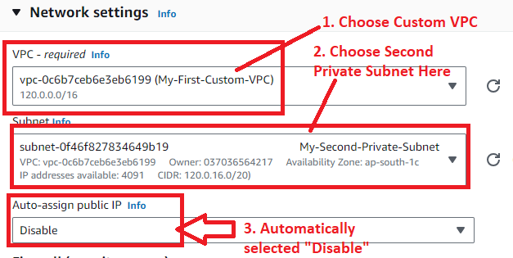

**Step 8: In** the **“Firewall (security groups)”, select** the **“Select existing security group”. Select** the **“Common security groups”** as the **“VPC-Private-Security-Group”.**

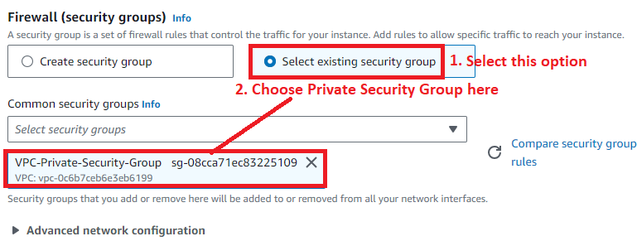

**Step 9: Leave** the **other settings** as **it is** & **click** on the **“Launch Instance”.**



**Step 10: The instance** will be **launched successfully. Click** on the **“hyperlink”, which** is an **instance id.**

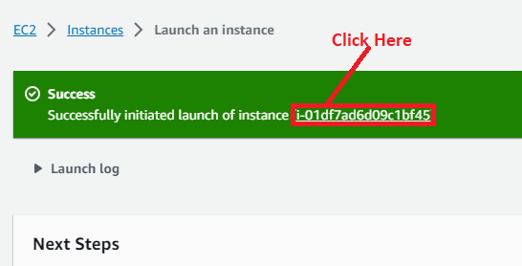

**Step 11: The instance** will be **in** the **“Running” State. It** means **our First Private Instance** has been **successfully created. The private Instance** can’t be **connected publicly that’s why we don’t have perform connection here. We** will **connect** throughthe **public Instance** after **both** the **private instance** creation**.**

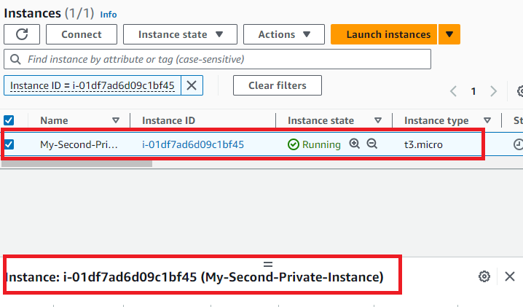

**H. Access Both Private Instances from the Public Instance**

**Step 1: Go** to the **Computer. Search** the **“Pagent” & click** on the **“OK”.**

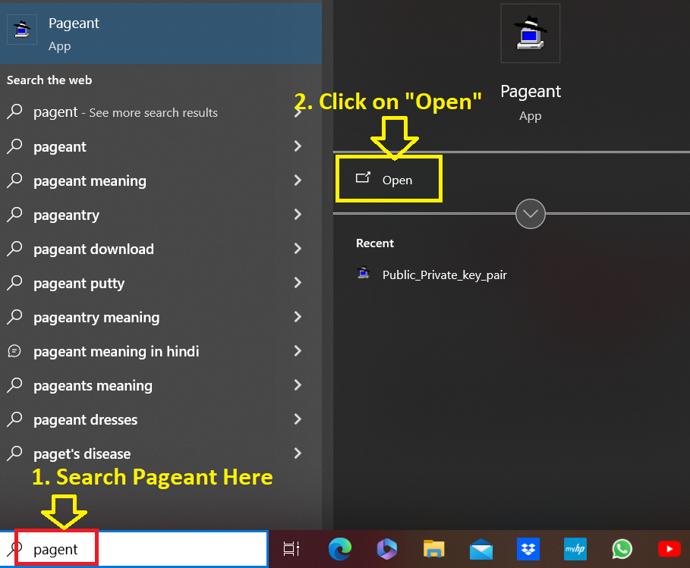

**Step 2: Put** the **cursor** overthe **“Pageant” icon** & **click** on the **“Add Key”.**

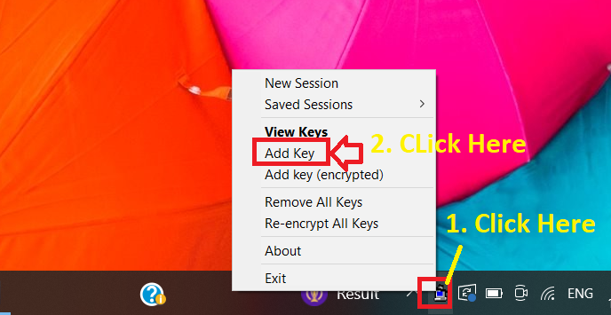

**Step 3: Select** the **“MY-WEB-SERVER.ppk” key file** & **click** on the **“Open”.**

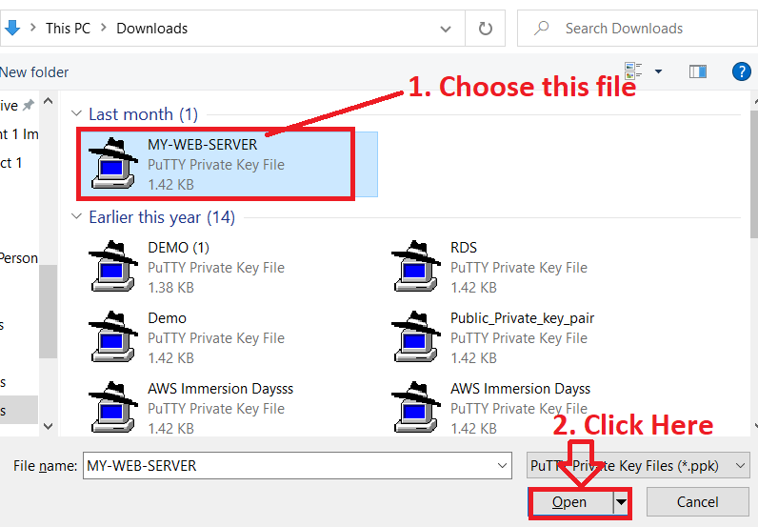

**Step 4: Click** on the **“Pagent” Icon** & **click** on the **“View keys”. You** will **notice** that **one key** has been **successfully added.**

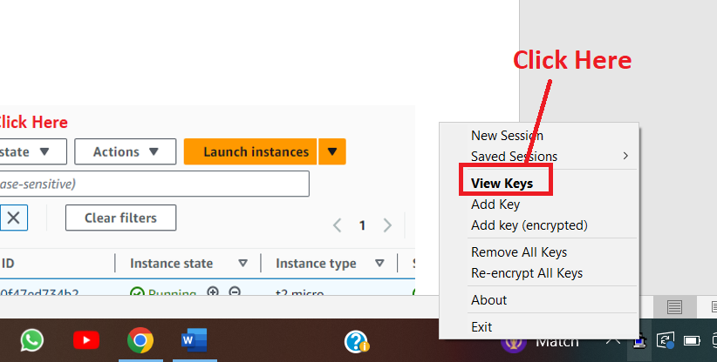

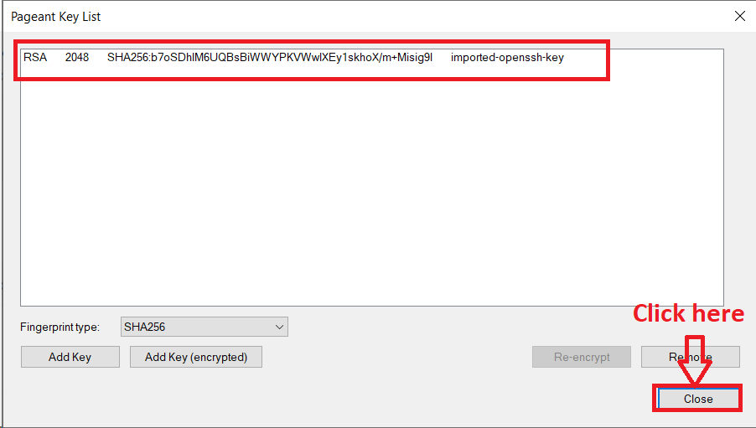

**Click** on the **“Close” after viewing** the **key.**

**Step 4: Search** the **“PuTTY”** in **the “Computer”** & **click** on the **“Open”.**

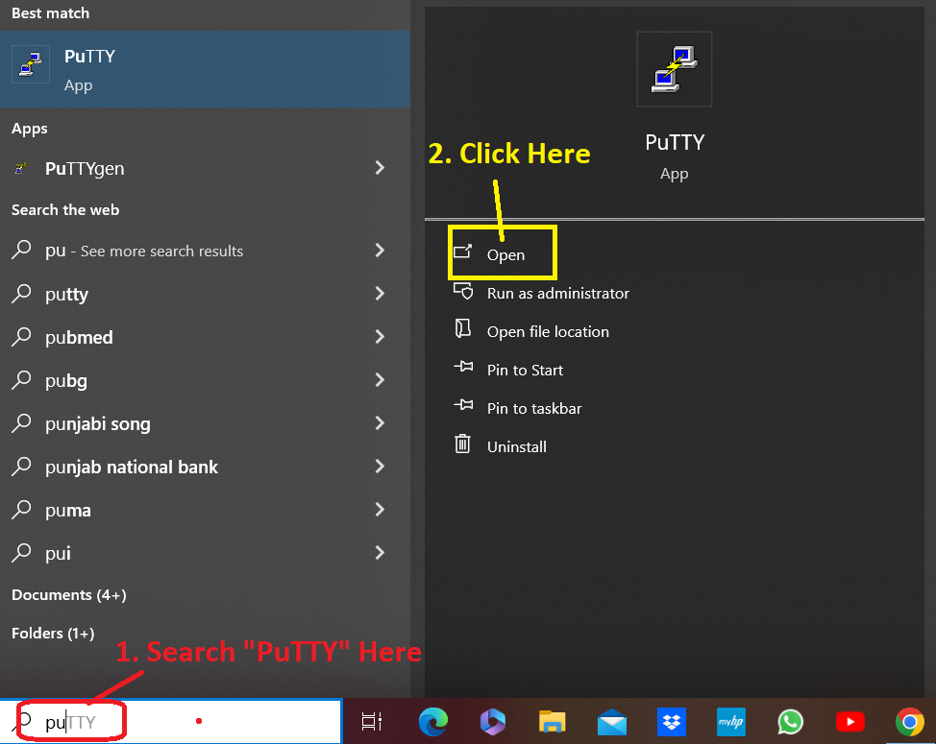

**Step 5: For** the **“Host Name or its IP Address”, you** must **go to** the **“Instances”** in the **AWS Account.**

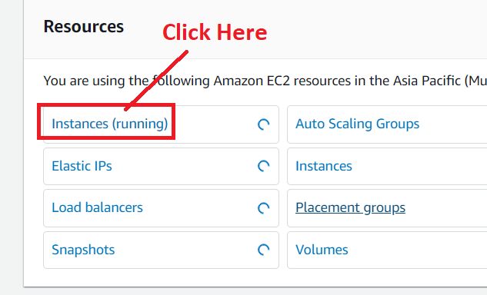

**Step 6: Select** the **“My-Public_Instance” & copy** the **“Public IP Address”.**

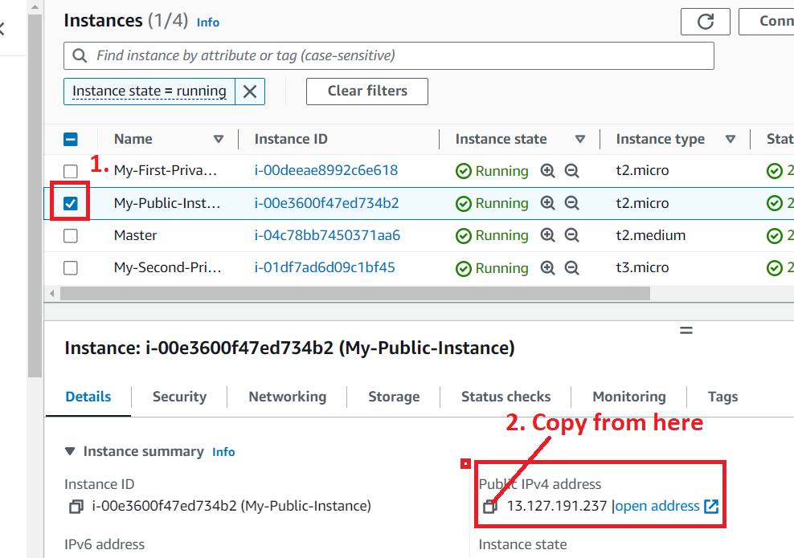

**Step 7: Paste** the **“IP Address (13.127.191.237)”** in the **“Host (or IP Address)” section** in the **“PuTTY”.**

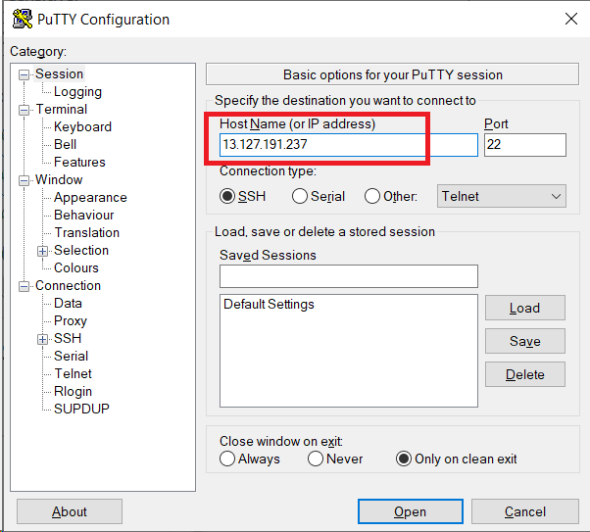

**Step 8: Go** tothe **“SSH>Auth keys”. Select** the **“Allow agent forwarding”** & **click** on the **“Open”.**

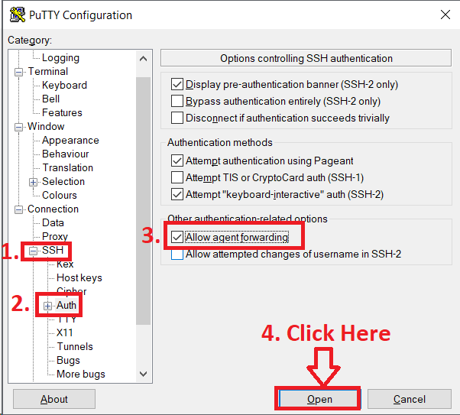

**Step 9: Type** the **“ec2-user” & press** the **“enter” from** the **keyboard. The instance** will be **successfully connected.**

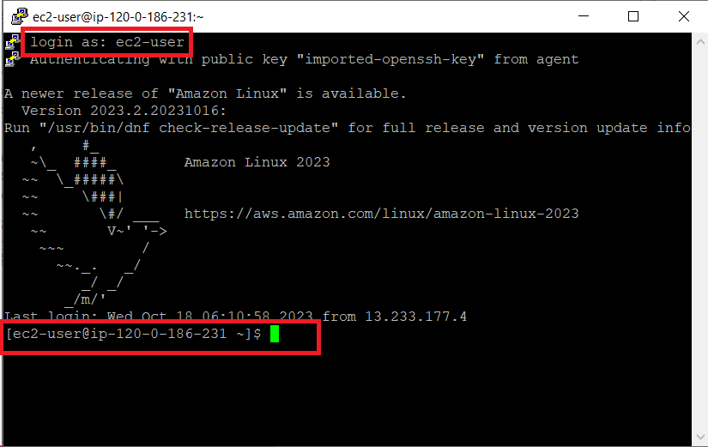

**The Above “IP Address”** in the **“EC2 User”** is the **“Private IP”** of the **“Public Instance”.**

**Step 10: Now, we** will **ping “google.com”** for **checking** the **internet connectivity. But we** must **add “ICMP” protocol** in **the attached “security group”.**

**Go** to the **“Security Groups”** & **select** the **“VPC-Security-Group”. Go** to the **“Actions>Edit Inbound rules”.**

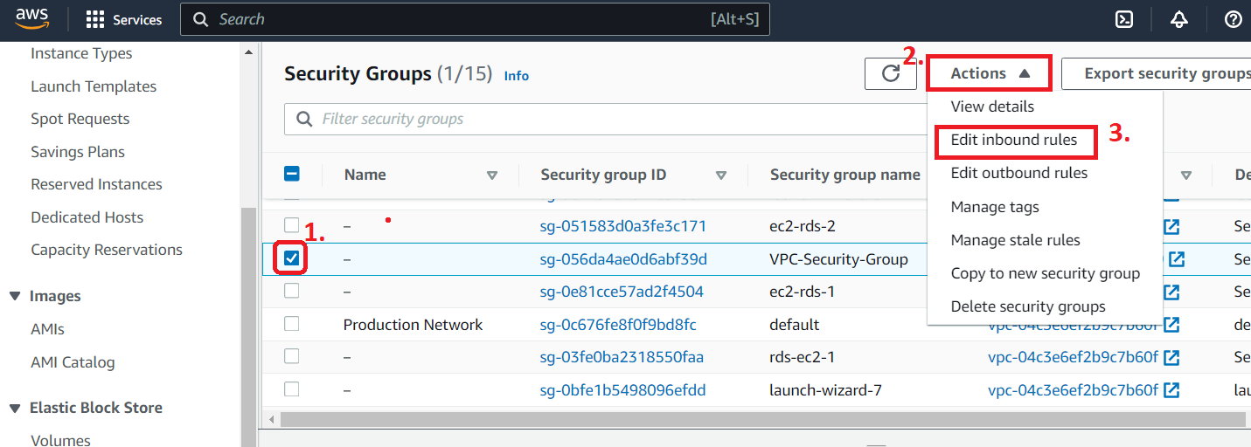

**Step 11: Click** on the **“Add rule”.**

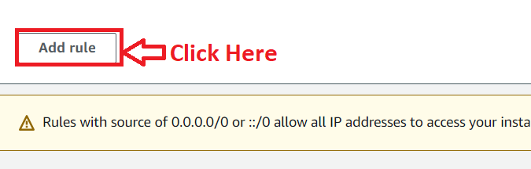

**Step 12: Select** the **“Type”** as the **“All ICMP-IPv4” &** the **“Source”** as **“Anywhere”. Click** onthe **“Save rules”.**

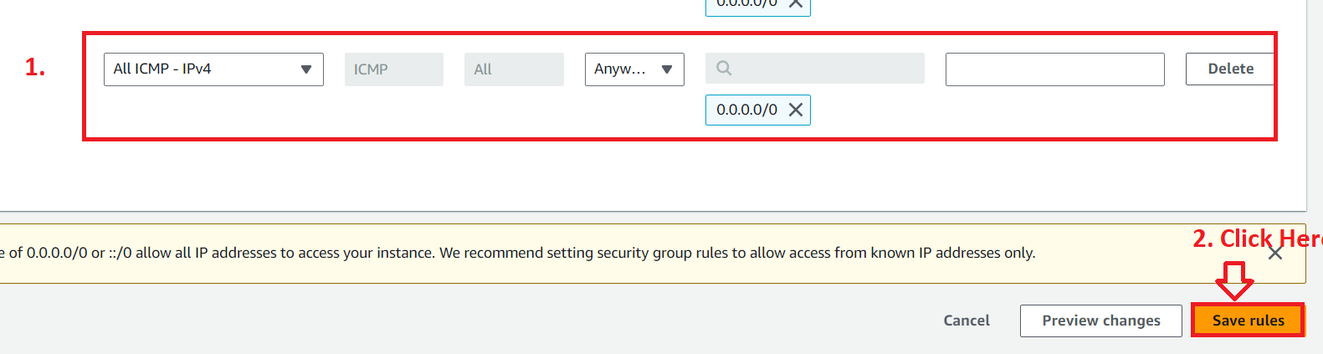

**Step 13: Type** the **command “ping** [**www.google.com**](http://www.google.com)**” in** the **“PuTTY” & pinging** will be **started. This means your public instance** is **successfully connecting** to the **internet.**

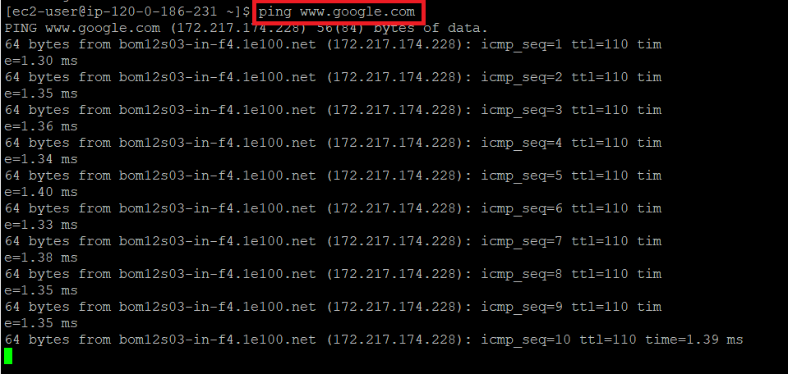

**Step 14: Go** to the **“Instances”. Select** the **First Private Instance** & **click** on the **“Connect”.**

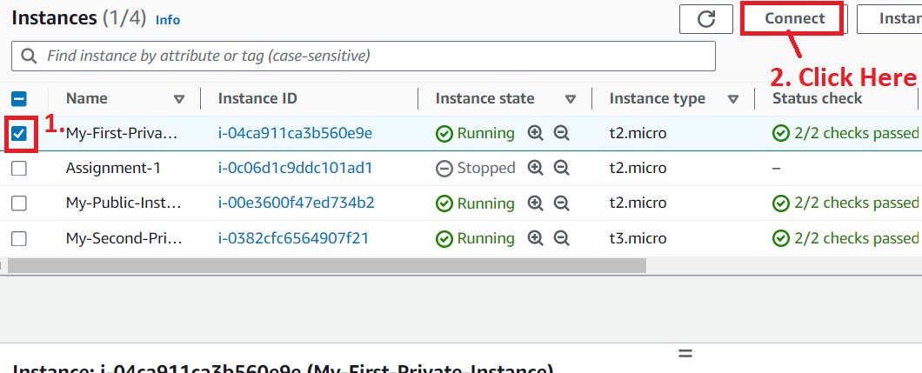

**Step 15: Go** to the **“SSH Client”. Copy** the **command** from **“SSH Client”.**

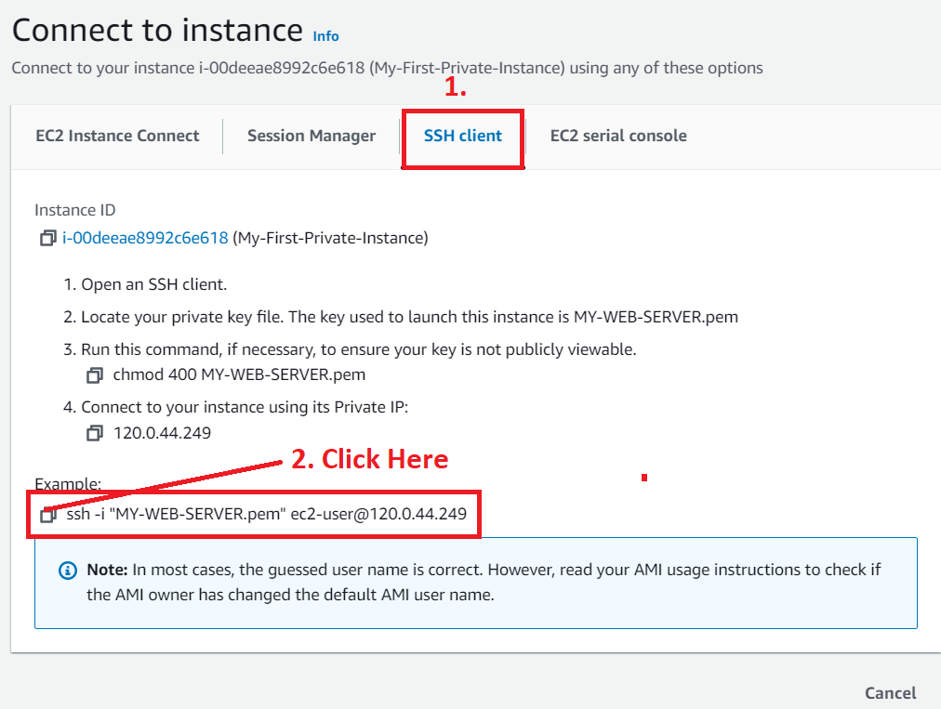

**Step 16: Paste** the **command & press “enter”** from the **keyboard. The Private instance** will be **successfully connected.**

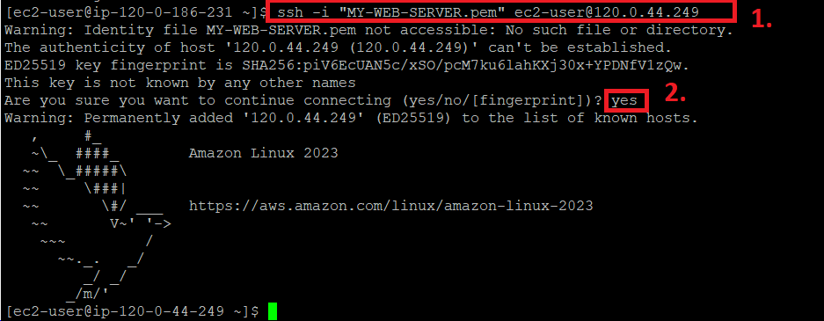

**Step 17: Type the command “ping** [**www.google.com**](http://www.google.com)**” in the “PuTTY” & pinging** will be **started. This means your first private instance** is **successfully connecting** to the **internet.**

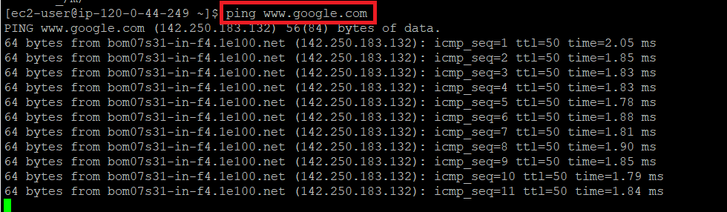

**Step 18: Now, we** are **closing** this **terminal** & **again access** the **public instance. After that, we** will **connect second private instance & will check** that **second private instance** is **successfully connecting** with the **internet or not.**

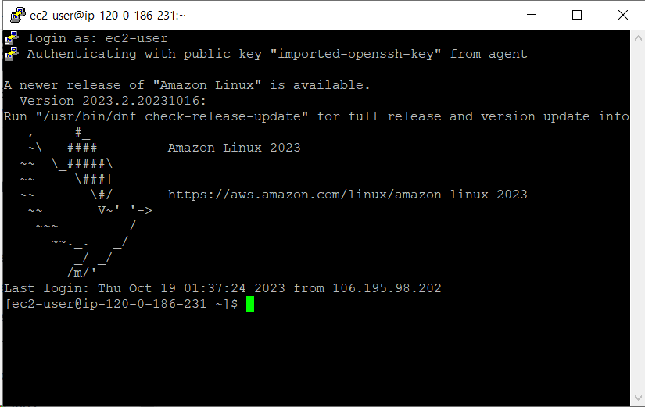

**Step 19: Go** to the **“Instances”** & **select** the **“My-Second-Private Instance”. Click** on the **“Connect”.**

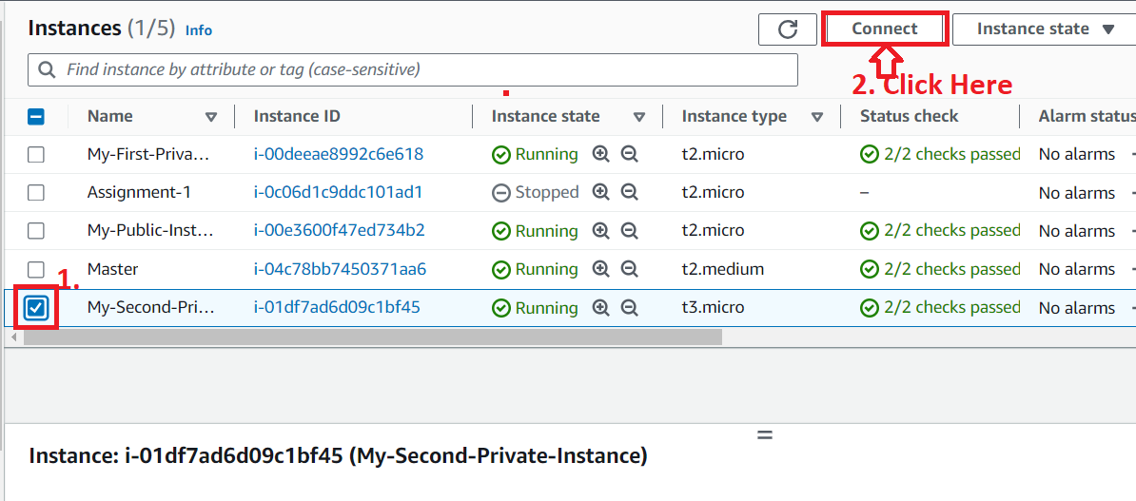

**Step 20: Copy** the **given command** from **here.**

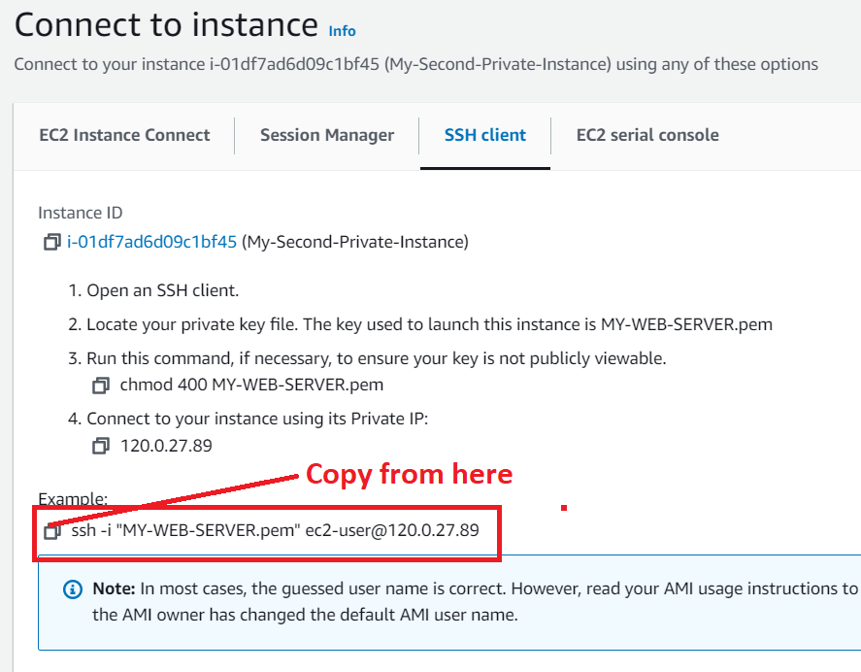

**Step 21: Paste** the **command** in the **“PuTTY” terminal. The “Second Instance”** will be **successfully connected.**

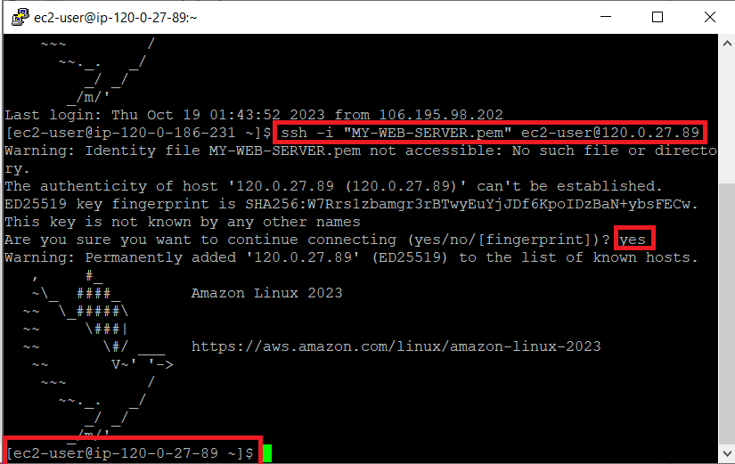

**Step 22: Type the command “ping** [**www.google.com**](http://www.google.com)**”** in the **“PuTTY” & the pinging** will be **started. This** means **your second private instance** is **successfully connecting** to the **internet.**

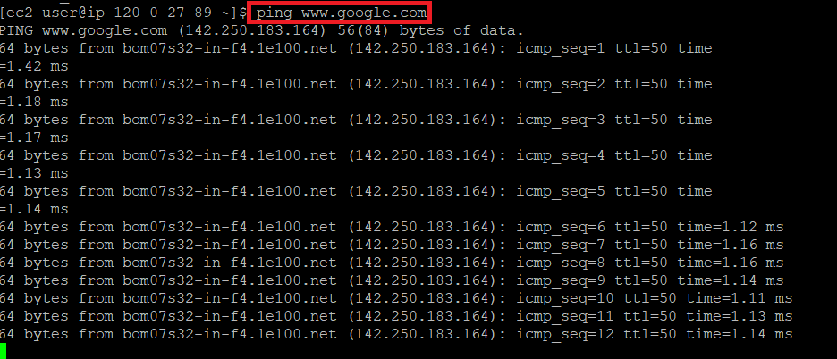

**🡨-----------------------Assignment Completed------------------------------------🡪**